**PROJECT REPORT**

**ON**

**STOCK MARKET-SIMULATOR**



**NATIONAL INSTITUTE OF TECHNOLOGY, KARNATAKA MASTER OF COMPUTER APPLICATIONS**

**2021-2022**

**Submitted By: Submitted To:**

ADARSH THAKUR (194CA002) Ms. TEJASWINI GONDHALE

RAVI KUMAR GAUTAM (194CA036)

RAJAT KUMAR JAIN (194CA035)

HARENDRA SINGH (184CA024)

MUKESH KUMAR GUPTA (184CA040)

# DECLARATION

We hereby declare that the work, which has been presented in this project report entitled “**STOCK MARKET SIMULATOR**” in partial fulfilment for the award of degree of **MASTER OF COMPUTER APPLICATIONS** from “**NATIONAL INSTITUTE OF TECHNOLOGY KARNATAKA**”, in department of mathematical and computer sciences is record of our own investigations carried under the guidance OF **Ms. TEJASWINI GONDHALE**.

**Name of the candidates:**

ADARSH THAKUR (194CA002)

RAVI KUMAR GAUTAM (194CA036)

RAJAT KUMAR JAIN (194CA035)

HARENDRA SINGH (184CA024)

MUKESH KUMAR GUPTA (184CA040)

# CERTIFICATE

This is to certify that the P.G. Project Work Report entitled **“STOCK MARKET SIMULATOR”** submitted by **’ADARSH THAKUR’**(Roll No:-194CA002),**’** **RAVI KUMAR GAUTAM’** (Roll No:- 194CA036), **‘RAJAT KUMAR JAIN’**(Roll No:-194CA035), **‘HARENDRA SINGH’**(Roll No:-184CA024) and, **‘MUKESH KUMAR GUPTA’**(Roll No:-184CA040) as the record of the work carried out by them, is accepted as the P.G. Project Work Report submission in partial fulfilment of the requirements for mandatory learning course of **MASTER OF COMPUTER APPLICATIONS** in the Department of **MATHEMATICAL AND COMPUTATIONAL SCIENCES.**

**ABSTRACT**

A stock market simulator is computer software that reproduces behaviour and features of a stock market, so that a user may practice trading stocks without financial risk. The use of an open-source, virtual stock exchange simulators can be seen as a viable alternative for various learners to train trading practice without risking loses of real funds. At present, there is a shortage of suitable tools that could allow entry level users to engage in a real market trading after gaining a certain degree of confidence from practicing in a both very practical and safe environment. We have built a stock market simulator using Python programming language.

**CONTENTS**

**Title Page no**

**1 Technologies used in project** 1

**2 Software and Hardware requirements** 2

**3 Results and Screenshots of simulator** 3-11

**4 Full Code** 12-14

**5 Conclusion** 15

**TECHNOLOGIES USED IN THE PROJECT**

**yfinance python library: -** It's an open-source tool that uses Yahoo's publicly available APIs, and is intended for research and educational purposes. Real-time data is available during an exchange's market hours, and in some cases during pre-market and post-market hours.

**Streamlit library: -** Streamlit is an open-source Python library that makes it easy to create and share beautiful, custom web apps. In just a few minutes you can build and deploy powerful data apps.

**PIL library:-** Python Imaging Library is a free and open-source additional library for the Python programming language that adds support for opening, manipulating, and saving many different image file formats.

1

**SOFTWARE AND HARDWARE REQUIREMENTS: -**

**Table 1: - MINIMUM HARDWARE REQUIREMENTS**

|  |  |  |
| --- | --- | --- |
| **Hardware** | **Minimum Requirements** | **Reason** |
| Processor speed | 1.6GHZ | Accommodate most pc |
| Memory of user pc | 512MB RAM | Relatively fast |
| Memory of server pc | 8GB | Fast |
| Disk space of server | 200GB | Adequate storage |

**Table 2: - MINIMUM SOFTWARE REQUIREMENTS**

|  |  |  |
| --- | --- | --- |
| **Software** | **Minimum requirements** | **Reason** |
| Operating system for pc | Windows 8,10, Mac | Accessed all locations |
| Browser | Firefox, chrome | Standard browser |

2

**HOME UI: -**

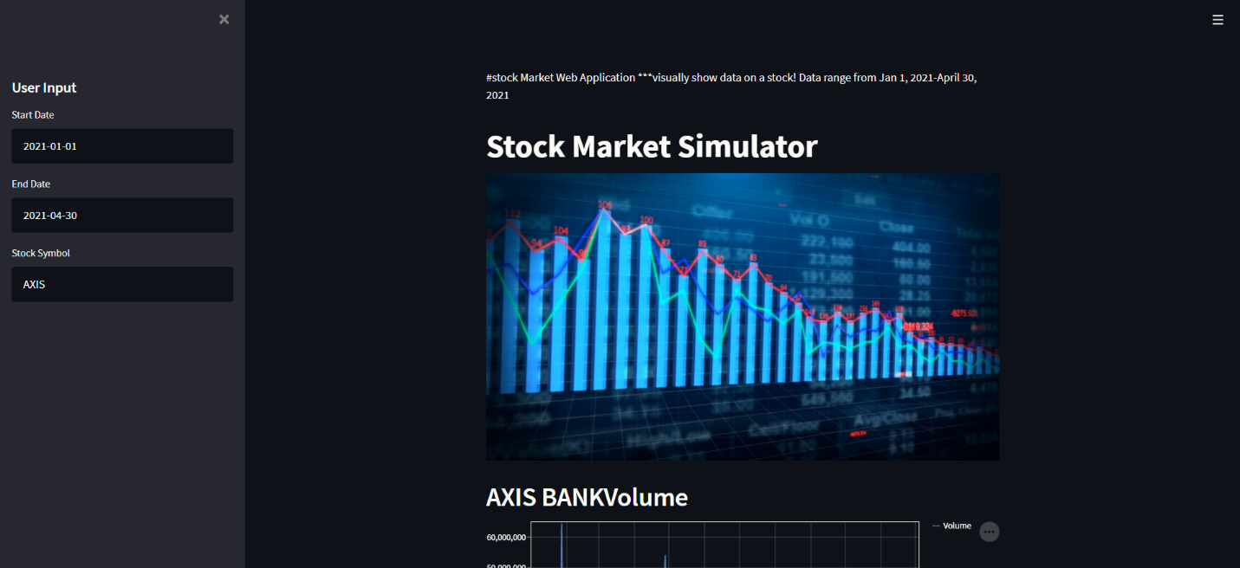

**Code: -**

#Import the libraries

import streamlit as st

from PIL import Image

import yfinance as yf

#Add a title and an image

st.write("""

#stock Market Web Application

***visually show data on a stock! Data range from Jan 1, 2021-April 30, 2021

""")

st.title('Stock Market Simulator')

image = Image.open("E:/learning/various technololgy learned/computer simulation project/Preview_Stock_Market_Data.jpg")

st.image(image, use_column_width=True)

#create a sidebar header

st.sidebar.header('User Input')

#create a function to get the users input

def get_input():

start_date = st.sidebar.text_input("Start Date", "2021-01-01")

end_date = st.sidebar.text_input("End Date", "2021-04-30")

stock_symbol = st.sidebar.text_input("Stock Symbol", "tsla")

return start_date, end_date, stock_symbol

#Get the users input

start, end, symbol = get_input()

tickerSymbol = symbol

tickerData = yf.Ticker(tickerSymbol)

tickerDf = tickerData.history(period='1d', start=start, end=end)

3

**Line Chart visualization of any Company’s Data: -**

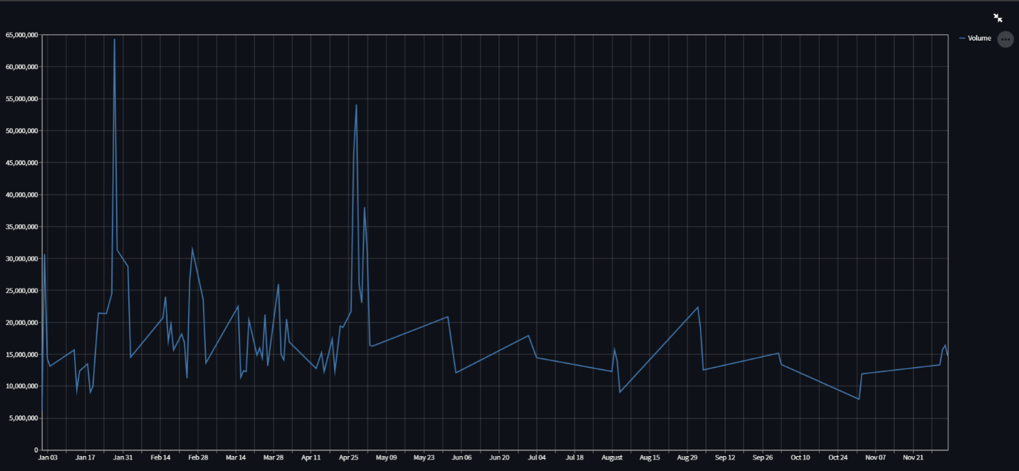

**Code: -**

st.header(tickerSymbol+" Volume\n")

st.line_chart(tickerDf['Volume'])

4

**Statistics of Company’s Data: -**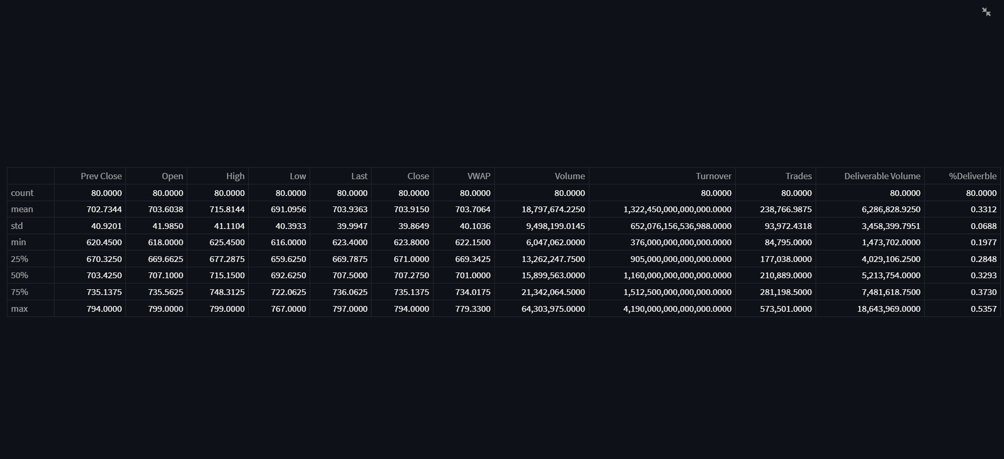

**Code: -**

st.header('Data Statistics')

st.write(tickerDf.describe())

5

**Company’s Calendar: -**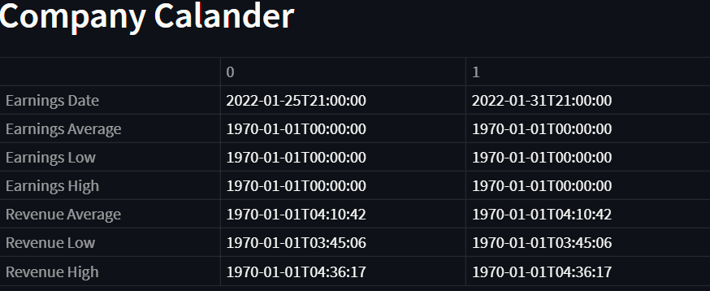

**Code: -**

st.header('Company Calander')

st.write(tickerData.calendar)

6

**Company Dividend Data: -**

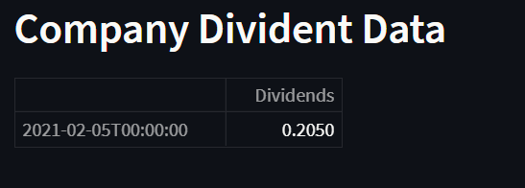

**Code: -**

st.header('Company Divident Data')

st.write(tickerData.dividends)

7

**Company Share Holders: -**

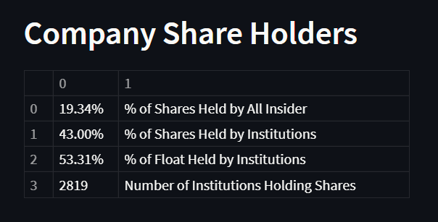

**Code: -**

st.header('Company Share Holders')

st.write(tickerData.major_holders)

8

**Company Institutional Investors: -**

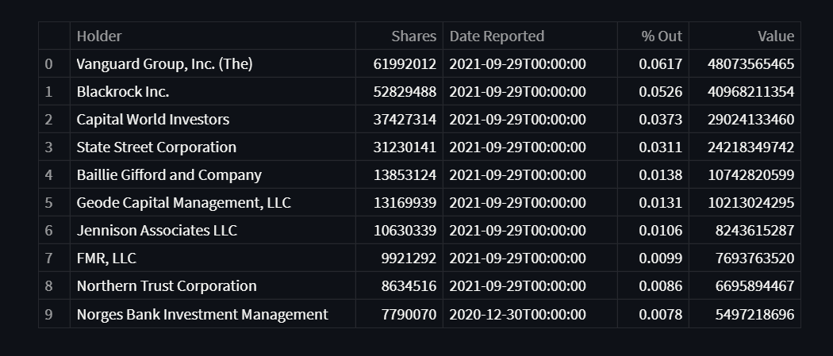

**Code: -**

st.header('Company Institutional Investors')

st.write(tickerData.institutional_holders)

9

**Company Recommendations: -**

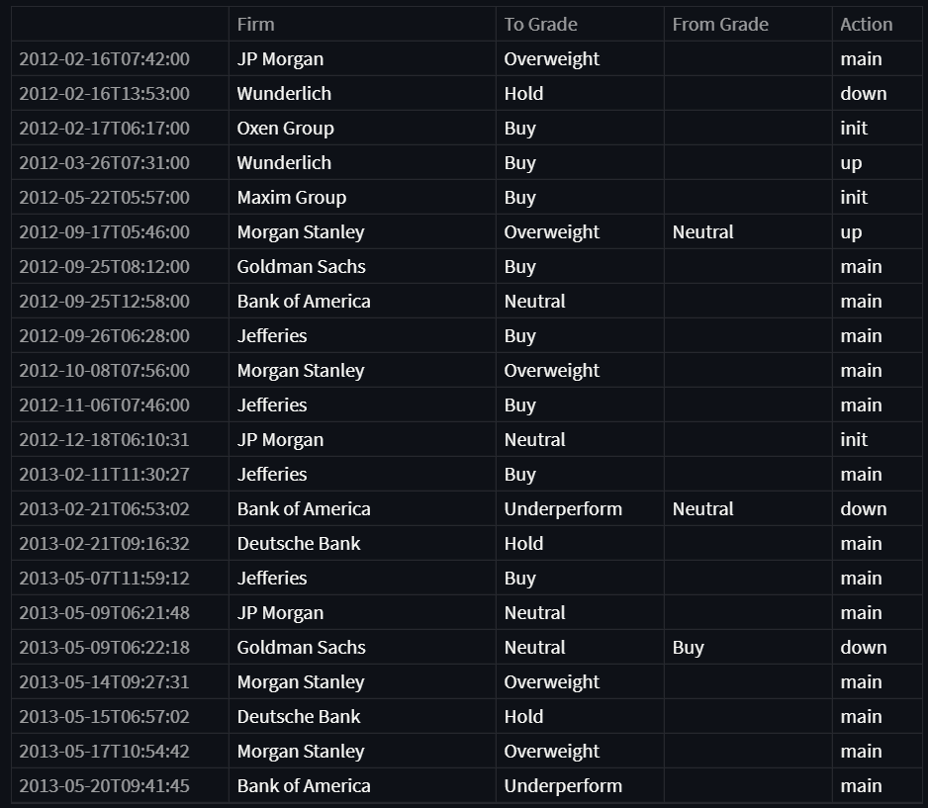

**Code: -**

st.header('Company Recommendations')

st.write(tickerData.recommendations)

10

**Json Format Company Data: -**

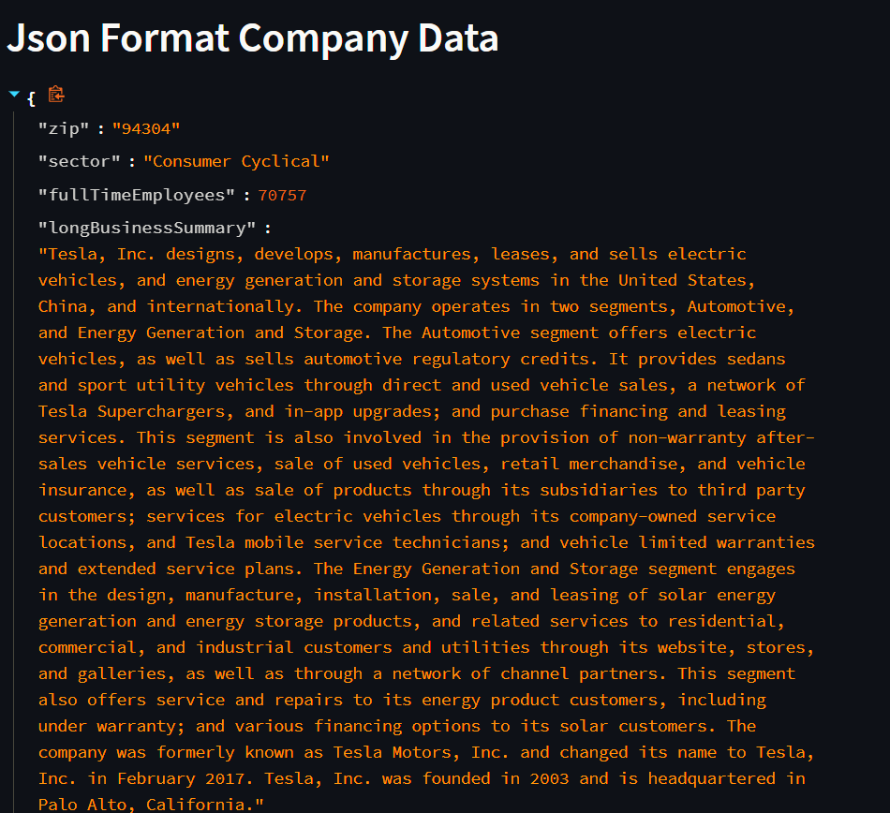

**Code: -**

st.header('Json Format Company Data')

st.write(tickerData.info)

11

**Full Code: -**

#Import the libraries

import streamlit as st

from PIL import Image

import yfinance as yf

#Add a title and an image

st.write("""

#stock Market Web Application

***visually show data on a stock! Data range from Jan 1, 2021-April 30, 2021

""")

st.title('Stock Market Simulator')

image = Image.open("E:/learning/various technololgy learned/computer simulation project/Preview_Stock_Market_Data.jpg")

st.image(image, use_column_width=True)

#create a sidebar header

st.sidebar.header('User Input')

#create a function to get the users input

def get_input():

start_date = st.sidebar.text_input("Start Date", "2021-01-01")

end_date = st.sidebar.text_input("End Date", "2021-04-30")

stock_symbol = st.sidebar.text_input("Stock Symbol", "tsla")

return start_date, end_date, stock_symbol

#Get the users input

start, end, symbol = get_input()

tickerSymbol = symbol

tickerData = yf.Ticker(tickerSymbol)

tickerDf = tickerData.history(period='1d', start=start, end=end)

#Display the close price

st.header(tickerSymbol+" Volume\n")

st.line_chart(tickerDf['Volume'])

# Get statistics ont he data

st.header('Data Statistics')

st.write(tickerDf.describe())

st.header('Company Calander') #“calendar” function can be used to know about the earnings and revenue of the company.

st.write(tickerData.calendar)

st.header('Company Divident Data') #A dividend can be described as a reward that publicly-listed companies extend to their shareholders. Dividends are sourced from company's net profits.

st.write(tickerData.dividends)

st.header('Company Share Holders')

st.write(tickerData.major_holders)

st.header('Company Institutional Investors')

st.write(tickerData.institutional_holders)

st.header('Company Recommendations')

st.write(tickerData.recommendations)

st.header('Json Format Company Data')

st.write(tickerData.info)

#stock symbol list

#https://stockanalysis.com/stocks/

#AAPL

#MSFT

#tsla

14

**CONCLUSION: -**

It helps to raise capital for business, mobilize savings for investment, facilitates the growth of companies, and enables profit sharing. It assists in creating investment opportunities for small investors, and raising capital for development projects taken up by the large organizations.

15